MICHELLE KRUGER
PRESIDENT

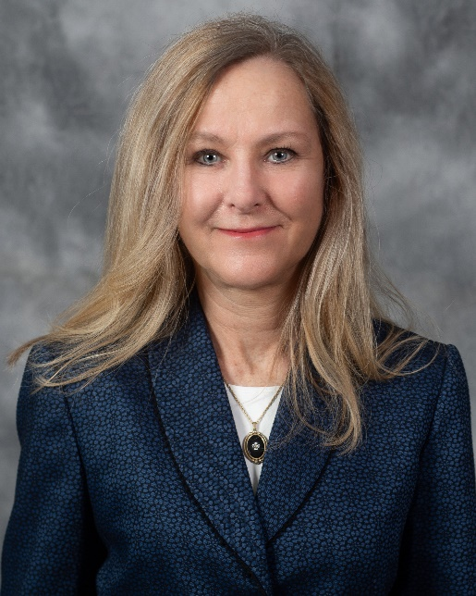
As Austal USA’s President, Michelle Kruger leads an organization of over 3,000 shipbuilding professionals headquartered in Mobile, Ala., with operations in Washington, D.C., San Diego and Singapore. She is responsible for all aspects of Austal USA’s ship manufacturing, service and support operations worldwide.

Kruger joined Austal USA in 2022 as the vice president of global services and support. In that role she led Austal USA’s ship repair and warranty efforts including the development of business strategy and strategic alliances. She also oversaw the stand up of Austal USA’s San Diego repair yard including the delivery of a purpose-built 9000-tonne capacity dry dock.

Kruger is a marine engineer with over 25 years of maritime industry experience in new construction, repair, and maintenance operations. Before joining Austal USA, she held a number of leadership positions across General Dynamics including Electric Boat where she supported the Virginia-class submarine program and led strategic business development activities. At General Dynamics NASSCO she was director of outfitting and led international benchmarking efforts that contributed to facility upgrades maximizing outfitting on the ground, and was director of repair administration. While at NASSCO she was promoted to vice president, new construction planning. She subsequently moved to General Dynamics Bath Iron Works (BIW) where she was vice president of operations and led a team of 4,000 building U.S. Navy DDG 51 Arleigh Burke-class destroyers.

Kruger earned a bachelor’s degree in marine engineering from the United States Merchant Marine Academy, was commissioned into the U.S. Navy reserves in 1987, and earned a master’s degree in marine engineering from Rensselaer Polytechnic Institute in 1995.

ABOUT AUSTAL USA

Austal USA is a ship manufacturer headquartered in Mobile, Ala., with service centers in San Diego and Singapore and a technology center in Charlottesville, Va. With the most modern steel panel line in the shipbuilding industry, Austal USA manufactures both aluminum and steel ships. Austal USA leverages a moving module production line and strict adherence to lean manufacturing principles to consistently deliver on-schedule and on-budget. Austal USA is under contract for several programs, including the U.S. Coast Guard’s Heritage-class Offshore Patrol Cutter (OPC), and the U.S. Navy TAGOS-25 ocean surveillance ship, Landing Craft Utility (LCU) vessel, Spearhead-class Expeditionary Fast Transport (EPF), Navajo-class Towing, Salvage and Rescue ship (T-ATS), Expeditionary Medical Ship (EMS), Auxiliary Floating Dry Dock Medium (AFDM), and Independence-variant Littoral Combat Ship (LCS) programs. Austal USA also supports Navy unmanned vessel programs leveraging its advanced autonomous machinery control system. Austal USA’s service business provides global support to U.S. Navy, Military Sealift Command and other customers. Austal USA’s San Diego Service Center includes a waterfront facility that has the capability to drydock small combatants and similar sized ships. Earning 27 safety excellence awards, Austal USA continues to be one of the safest shipyards in America.

